YABA COLLEGE OF TECHNOLOGY
SCHOOL OF TECHNOLOGY
DEPARTMENT OF COMPUTER TECHNOLOGY
(Networking & Cloud Computing)

COURSE TITLE: NETWORKING TROUBLESHOOTING AND MONITORING

COURSE CODE: NCC 414

TOPIC: UNDERSTAND VIRTUAL AND CLOUD NETWORK TROUBLESHOOTING

LECTURER: MR. OJO OLANREWAJU

GROUP: GROUP FIVE (5)

SUBMITTED BY THE FOLLOWING STUDENTS:
ADETUNJI ROFIAT FUMILAYO – F/HD/24/3212006
OLAOJO ANU JANET – F/HD/24/3212028
JOLAOSHO HANNAH ARIKEADE – F/HD/24/3212033
ADAMS OLAMIDE EMMANUEL – F/HD/24/3212035
ADEAGBO HABIDEEN TEMITAYO – F/HD/24/3212042
OLAYEMI MARIAM ABIODUN – F/HD/24/3212054
ADEGBITE TIMILEHIN JULIUS – F/HD/24/3212059
IJAOLA SAHEED DOLAPO – F/HD/24/3212067
IYIOLA HAFEEZ OMOGBOLAHAN – F/HD/24/3212097
OLABISI ABAYOMI SAMSON – F/HD/24/3212101

Table of Contents
1. Introduction
2. Understanding Network Virtualization
3. Virtual Switches, Routers, and Overlay Problems
4. Virtual Network Logs and Performance Metrics
5. Networking in Cloud Environments
6. Connectivity Issues in the Cloud
7. Performance Issues in the Cloud
8. Cloud Network Logs and Metrics
9. Cloud Network Configuration Problems
10. Step-by-Step Cloud Connectivity Troubleshooting
11. Accessing and Analyzing Cloud Logs & Metrics
12. Conclusion
13. References

1. Introduction
Virtualization and cloud computing have transformed modern IT infrastructure by abstracting network resources from physical hardware. However, this abstraction introduces unique troubleshooting challenges. This document provides a comprehensive overview of network virtualization, common issues in virtual and cloud environments, the role of logs and performance metrics, and best practices for configuration and monitoring. Understanding these concepts is essential for network administrators and cloud engineers to maintain efficient, secure, and reliable systems.

1.1 Explanation of Network Virtualization
Network virtualization is the process of creating a logical, software-based version of network resources such as switches, routers, firewalls, and network interfaces. It allows multiple virtual networks to operate independently on a single physical infrastructure.
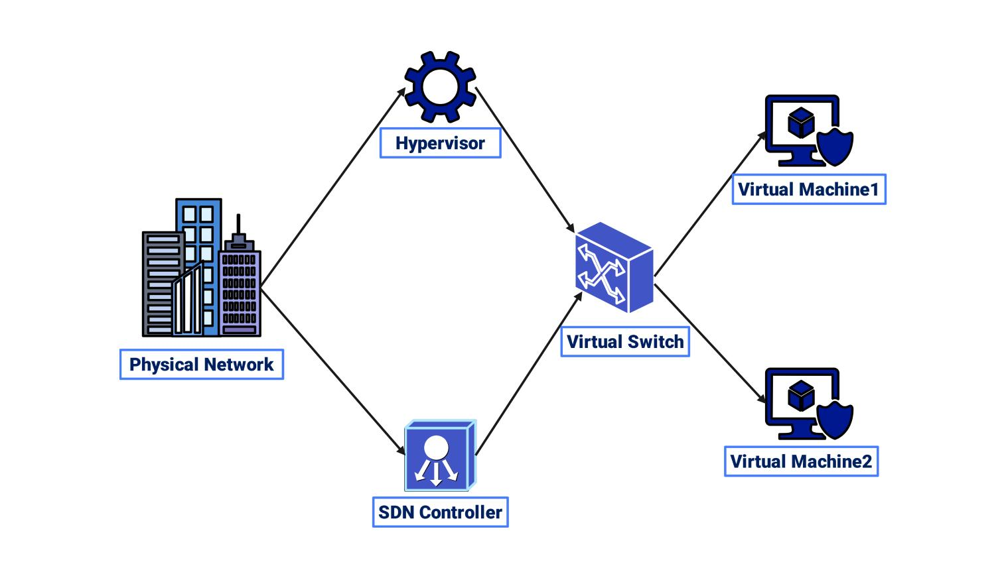
Network virtualization is the process of creating a logical, software-based version of network resources such as switches, routers, firewalls, and network interfaces.

Components of Network Virtualization
- Virtual Machines (VMs): Software-based computers running their own OS.
- Virtual Network Interface Cards (vNICs): Allow VMs to connect to networks.
- Virtual Switches (vSwitches): Connect VMs to each other and to external networks.
- Virtual Routers & Firewalls: Control traffic and provide security between networks.

Common Network Virtualization Platforms
A. VMware in Network Virtualization
VMware is a leading network virtualization platform that allows you to create and manage virtual networks, machines, and network services using software instead of physical hardware. It is widely used in data centers, cloud environments, and enterprise networks.
What VMware Does in Network Virtualization
VMware separates (abstracts) networking from physical devices and recreates it in software. This means you can build a complete network—switches, routers, and firewalls—inside a computer or across multiple servers.
Benefits
- Reduces need for physical networking hardware
- Easy to create, modify, and manage networks
- High scalability for growing systems
- Strong security and network isolation Key Components

B. VirtualBox in Network Virtualization
VirtualBox is a free, user-friendly virtualization platform that allows you to create and manage virtual machines (VMs) and connect them through virtual networks. It is widely used for learning, testing, and small-scale network simulations.
How VirtualBox Works in Network Virtualization
VirtualBox creates a software-based network environment where multiple VMs can communicate with each other and with external networks—just like real computers on a physical network.
Benefits
- Free and open-source
- Easy to install and use
- Supports multiple operating systems
- Flexible network configuration options
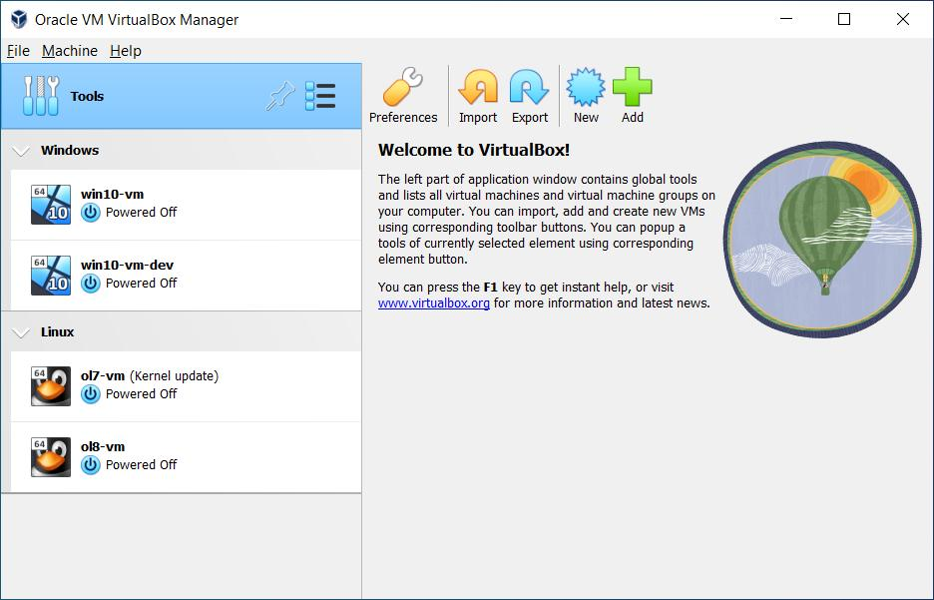
C. Hyper-V in Network Virtualization
Hyper-V is Microsoft’s built-in virtualization platform used to create and manage virtual machines (VMs) and virtual networks on Windows systems. It is commonly used in enterprise environments and supports advanced network virtualization features.
How Hyper-V Works in Network Virtualization
Hyper-V creates a software-based networking system where virtual machines communicate using virtual switches instead of physical network devices. This allows multiple isolated networks to run on one physical computer.
Benefits
- Reduces need for physical networking hardware
- Enables secure and isolated virtual networks
- Supports enterprise-level scalability
- Allows testing of complex network setups
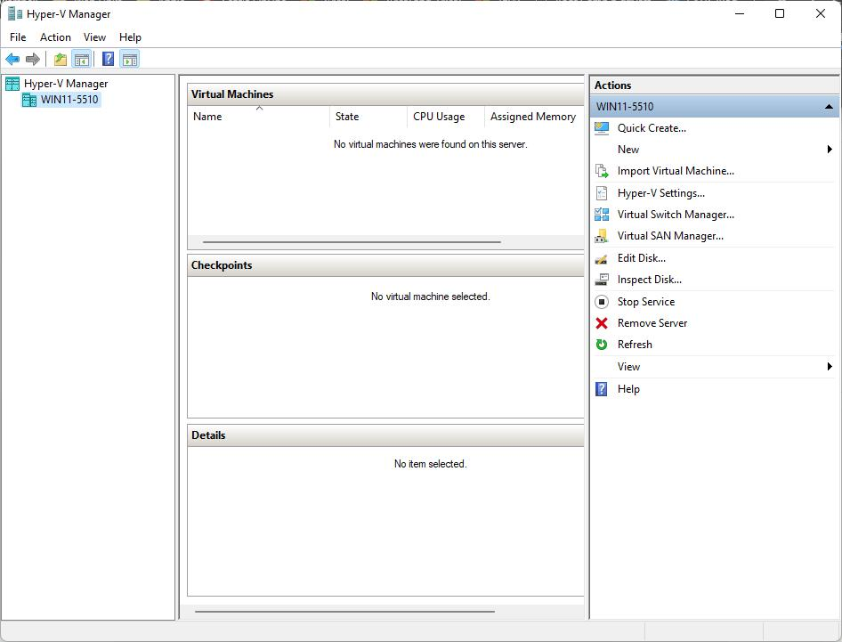

1.2 Common Issues in Virtualized Network Environments and Their Causes
1. Network Connectivity Issues: This occurs when virtual machines (VMs) cannot communicate with other VMs, the host system, or external networks.
Causes:
- Misconfigured virtual Network Interface Cards (vNICs)
- Incorrect IP address, subnet mask, or gateway settings
- Disabled or disconnected virtual adapters
- Wrong network mode (NAT, Bridged, or Host-only)
- Faulty virtual switch configuration
2. Performance Degradation: Virtual networks may experience slow data transfer or delayed response times.
Causes:
- Overloaded physical host (CPU, RAM, or disk bottlenecks)
- Too many VMs sharing limited resources
- Bandwidth contention among virtual machines
- Poor resource allocation or limits set in the hypervisor
- Inefficient or outdated network drivers
3. Packet Loss: Packet loss refers to data packets failing to reach their destination.
Causes:
- Network congestion within the virtual environment
- Misconfigured virtual switches or NICs
- Buffer overflow in host or VM
- Faulty drivers or outdated virtualization tools
4. High Latency: Latency is the delay in data transmission between source and destination.
Causes:
- Heavy workload on the host machine
- Improper CPU scheduling for VMs
- Network overlay overhead (e.g., encapsulation)
- Long data paths due to poor network design
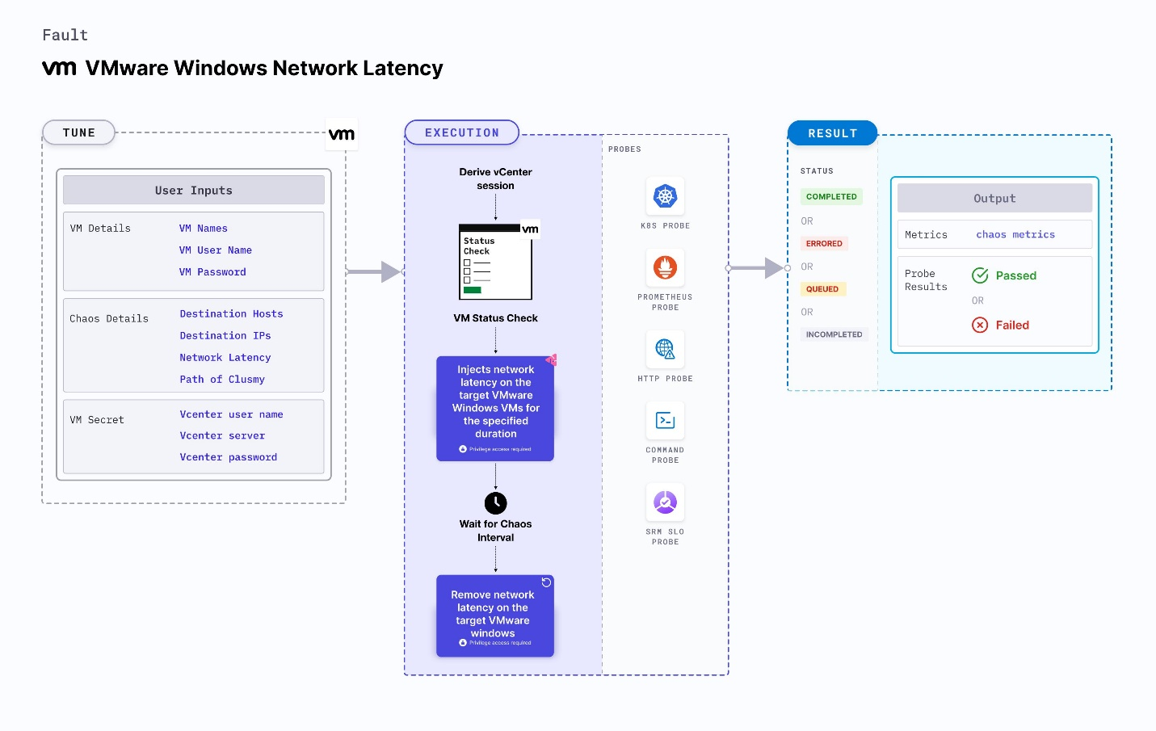
5. Virtual Switch Misconfiguration: Virtual switches connect VMs and manage traffic flow.
Causes:
- Incorrect VLAN configuration
- Port group misassignment
- Disabled ports or incorrect security policies
- Broadcast storms due to looped configurations
6. IP Address Conflicts: Occurs when two or more devices share the same IP address.
Causes:
- Manual IP assignment errors
- Improper DHCP configuration
- Cloned VMs retaining old network settings
7. Security Issues: Virtual networks can be vulnerable if not properly secured.
Causes:
- Lack of proper isolation between VMs
- Weak firewall or access control rules
- Unauthorized access to virtual switches
- Poor patch management
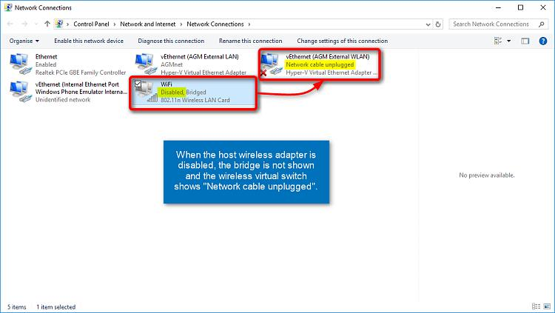

1.3 Problems Related to Virtual Switches, Routers, and Network Overlays and Their Causes
A. Problems Related to Virtual Switches;
A virtual switch (vSwitch) connects virtual machines to each other and to external networks, similar to a physical switch.
Common Problems:
1. VLAN Misconfiguration
- Issue: VMs cannot communicate even when on the same network.
- Causes: Incorrect VLAN ID assignment; mismatch between virtual switch and physical switch VLANs; trunking not properly configured.
2. Port Group Misassignment
- Issue: VM is connected to the wrong network segment.
- Causes: Incorrect port group selection; mislabeling of network groups.
3. Broadcast Storms
- Issue: Excessive broadcast traffic slows down or crashes the network.
- Causes: Network loops in virtual switch configuration; lack of loop prevention protocols like STP.
4. Security Policy Misconfiguration
- Issue: Unauthorized access or blocked legitimate traffic.
- Causes: Incorrect MAC filtering; promiscuous mode enabled unnecessarily; weak access control policies.
5. NIC Teaming Issues
- Issue: Loss of redundancy or load balancing failure.
- Causes: Improper NIC teaming configuration; failure of one physical NIC without proper failover setup.
B. Problems Related to Virtual Routers;
Virtual routers manage traffic between different networks and subnets in virtual environments.
Common Problems:
1. Routing Misconfiguration
- Issue: Traffic cannot reach destination networks.
- Causes: Incorrect routing tables; missing static or dynamic routes.
2. NAT (Network Address Translation) Failures
- Issue: VMs cannot access external networks (e.g., the internet).
- Causes: Incorrect NAT rules; misconfigured gateway settings.
3. IP Address Conflicts
- Issue: Network communication disruption.
- Causes: Duplicate IP addresses; poor IP address management.
4. Firewall Rule Errors
- Issue: Blocked or unrestricted traffic.
- Causes: Overly restrictive firewall settings; missing rules for required services.
5. High CPU Usage in Virtual Routers
- Issue: Slow routing performance.
- Causes: Excessive traffic load; insufficient resource allocation.

C. Problems Related to Network Overlays;
Network overlays (e.g., VXLAN, NVGRE) create logical networks on top of physical infrastructure, often used in cloud and large-scale virtual environments.
Common Problems:
1. Encapsulation Overhead
- Issue: Increased latency and reduced performance.
- Causes: Extra headers added to packets; processing overhead on hosts.
2. MTU (Maximum Transmission Unit) Mismatch
- Issue: Packet fragmentation or drops.
- Causes: Physical network MTU smaller than overlay requirements; improper MTU configuration across devices.
3. Tunnel Misconfiguration
- Issue: Failure in communication between overlay networks.
- Causes: Incorrect tunnel endpoints; misconfigured tunnel IDs (e.g., VNI in VXLAN).
4. Scalability Challenges
- Issue: Difficulty managing large networks.
- Causes: Poor network design; lack of proper segmentation.
5. Troubleshooting Complexity
- Issue: Difficult to identify root causes of issues.
- Causes: Multiple abstraction layers (virtual + physical); limited visibility into overlay traffic.

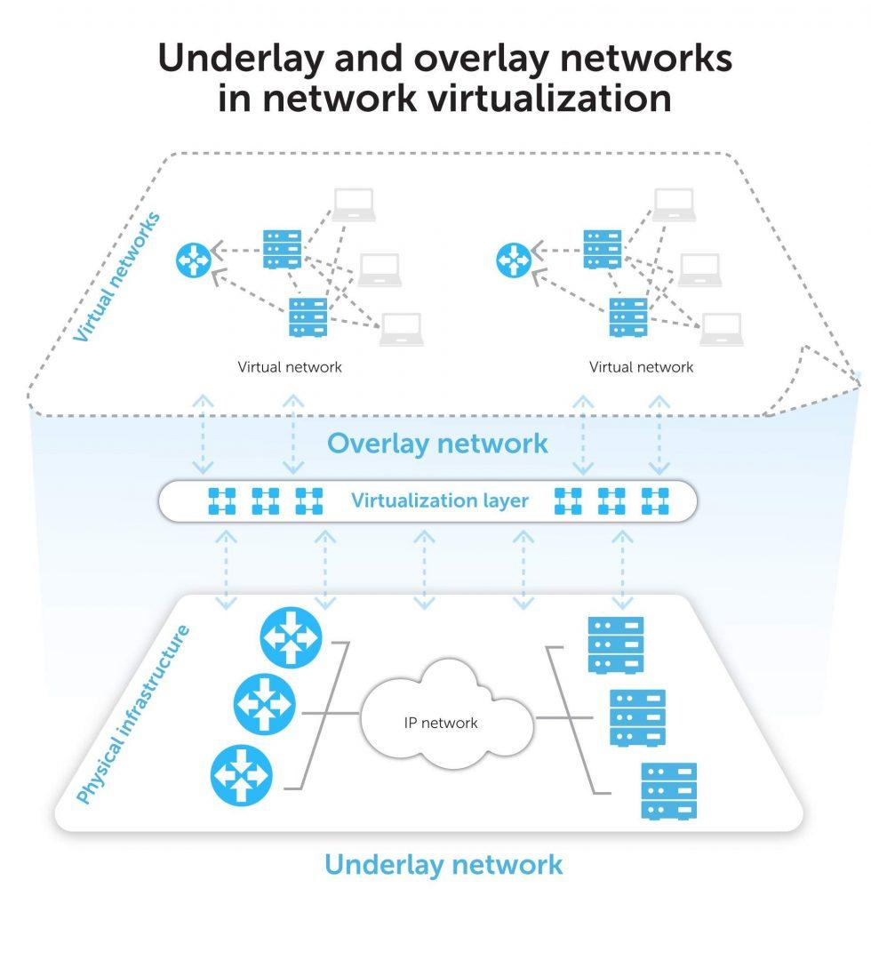

1.4 Virtual Network Logs and Performance Metrics
A. Virtual Network Logs;
Virtual network logs are records of events and activities that occur within virtual networking components such as virtual machines (VMs), hypervisors, and virtual switches.
Types of Virtual Network Logs
1. Hypervisor Logs – Generated by the hypervisor (e.g., VMware ESXi, Hyper-V).
- Contents: VM start/stop events, network configuration changes, resource allocation details, system errors and warnings.
- Importance: Helps detect host-level issues; identifies failures affecting multiple VMs.
2. Virtual Machine (VM) Network Logs – Maintained by each VM.
- Contents: IP address assignments, connection attempts and failures, application-level network errors.
- Importance: Useful for diagnosing connectivity issues inside a VM; helps track unauthorized access attempts.
3. Virtual Switch Logs – Track traffic and configuration changes.
- Contents: Port activity, VLAN configurations, packet forwarding information, security policy enforcement.
- Importance: Helps identify misconfigurations; detects unusual traffic patterns.
4. Firewall and Security Logs – Generated by virtual firewalls.
- Contents: Allowed and blocked traffic, intrusion detection alerts, access control violations.
- Importance: Enhances network security monitoring; helps in threat detection and response.
B. Performance Metrics in Virtual Networks;
Performance metrics are measurable values used to evaluate the efficiency, reliability, and health of a virtual network.
Metric | Definition | Indicates
Latency | Time for data to travel from source to destination | Network delay; possible congestion or routing issues
Throughput | Amount of data transmitted successfully over time | Network capacity and efficiency; bandwidth utilization
Packet Loss | Percentage of packets failing to reach destination | Network congestion; faulty configurations or hardware
Jitter | Variation in packet arrival time | Network instability; problems in real-time applications (VoIP, video calls)
Bandwidth Usage | Amount of network capacity being used | Traffic load; potential bottlenecks
CPU and Memory Utilization | Resource usage by VMs and host systems | Resource contention; overloaded systems affecting network performance

C. Importance of Logs and Metrics;
- Help in troubleshooting network issues
- Provide real-time monitoring and alerts
- Enable performance optimization
- Assist in capacity planning
- Improve security and compliance
D. Tools for Monitoring Virtual Networks;
Built-in Tools:
- VMware vSphere
- Hyper-V Manager
Third-Party Tools:
- Wireshark (packet analysis)
- Nagios (network monitoring)
- SolarWinds (performance monitoring)
- PRTG Network Monitor
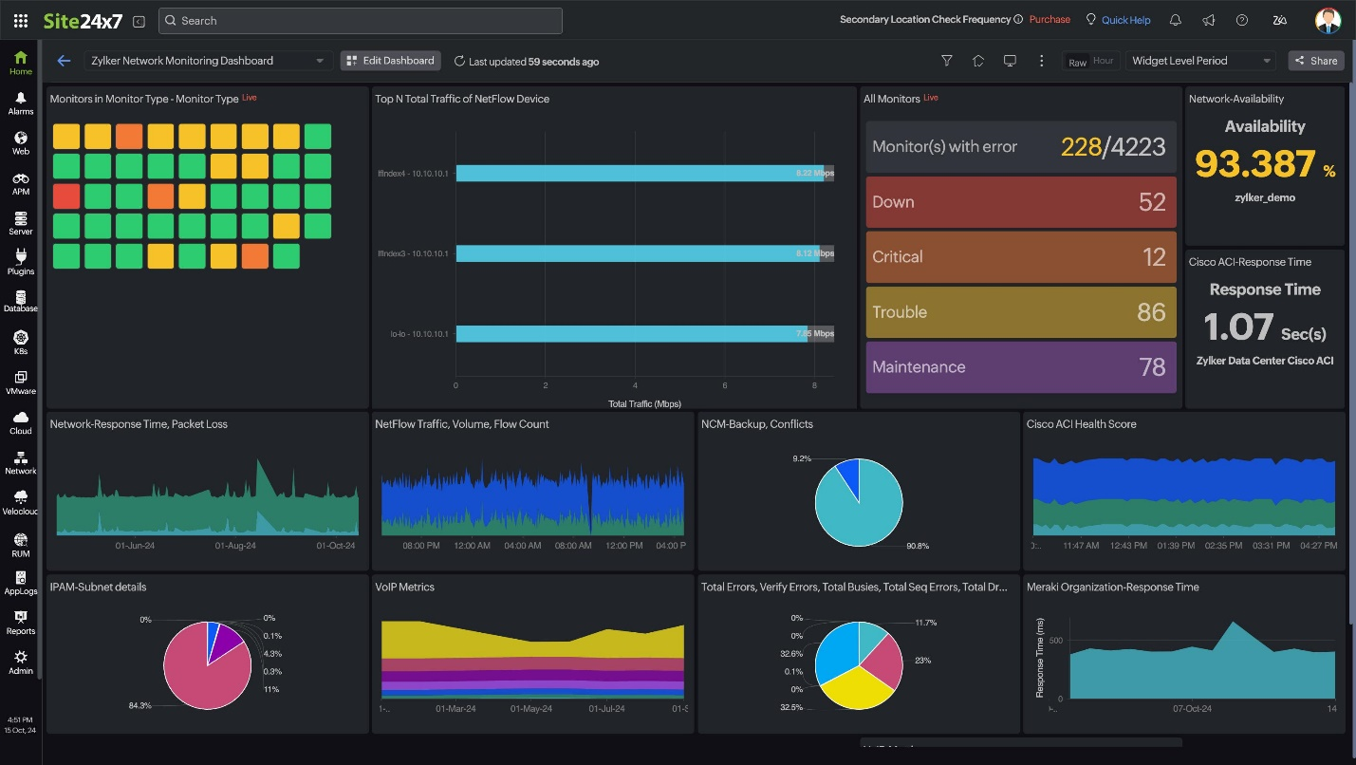

1.5 Networking in Cloud Environments
A. Definition;
Cloud networking refers to the use of cloud-based infrastructure to deliver network services such as routing, switching, security, and connectivity over the internet. Instead of relying solely on physical hardware, organizations use virtualized resources provided by cloud service providers.
B. Types of Cloud Networking;
1. Public Cloud Network – Shared infrastructure managed by a cloud provider; accessible over the internet. Example: Hosting a website on AWS.
2. Private Cloud Network – Dedicated infrastructure for a single organization; provides higher security and control.
3. Hybrid Cloud Network – Combination of public and private cloud; allows data and applications to move between environments.
C. Key Components of Cloud Networking;
1. Virtual Private Cloud (VPC) – A logically isolated virtual network within a cloud environment.
- Features: Custom IP address ranges, subnets, routing control.
2. Subnets – Divide a VPC into smaller segments.
- Types: Public subnet (accessible from the internet) and private subnet (internal use only).
3. Internet Gateway – Allows communication between cloud resources and the internet.
4. NAT Gateway – Enables private subnets to access the internet while preventing inbound connections.
5. Route Tables – Direct traffic within and outside the VPC.
6. Security Groups & Network ACLs – Control inbound and outbound traffic at the instance and subnet levels.

D. How Cloud Networking Works;
- Resources (VMs, containers) are deployed inside a VPC
- Subnets organize these resources into logical groups
- Route tables direct traffic within and outside the network
- Gateways provide internet access
- Security rules regulate traffic flow
E. Advantages of Cloud Networking;
- Scalability – Easily increase or decrease resources
- Flexibility – Configure networks quickly via APIs
- Cost Efficiency – Pay only for what you use
- Remote Access – Access services from anywhere
- High Availability – Redundant systems reduce downtime
F. Challenges of Cloud Networking;
- Security risks if misconfigured
- Latency due to distance from data centers
- Dependence on internet connectivity
- Complexity in large-scale or multi-cloud deployments

1.6 Causes of Network Connectivity and Performance Issues in Cloud Environments
A. Causes of Network Connectivity Issues;
Connectivity issues occur when cloud resources cannot communicate with each other or with external networks.
1. Misconfigured Security Groups and Firewalls
- Explanation: Security groups act as virtual firewalls controlling traffic.
- Causes: Blocking required ports (e.g., HTTP 80, HTTPS 443, SSH 22); overly restrictive inbound/outbound rules; missing rules for specific services.
2. Incorrect Routing Tables
- Explanation: Routing tables determine how traffic flows within the cloud network.
- Causes: Missing routes to destination networks; incorrect gateway configurations; misconfigured subnet routing.
3. DNS Resolution Failures
- Explanation: Domain Name System (DNS) translates domain names into IP addresses.
- Causes: Incorrect DNS server settings; unreachable DNS servers; misconfigured domain records.
4. Internet Gateway or NAT Gateway Issues
- Explanation: These components enable internet access for cloud resources.
- Causes: Gateway not attached to the VPC; incorrect NAT configuration; failure in gateway services.
B. Causes of Performance Issues;
Performance issues affect the speed, reliability, and responsiveness of cloud network services.
1. High Latency
- Explanation: Delay in data transmission across the network.
- Causes: Long physical distance between users and data centers; inefficient routing paths; network congestion.
2. Bandwidth Limitations
- Explanation: Limited data transfer capacity.
- Causes: Insufficient bandwidth allocation; excessive traffic load; shared cloud resources leading to contention.
3. Resource Contention
- Explanation: Multiple workloads competing for resources.
- Causes: Overloaded virtual machines; shared infrastructure in public clouds; poor resource allocation.
4. Load Balancer Misconfiguration
- Explanation: Load balancers distribute traffic across servers.
- Causes: Uneven traffic distribution; health check failures; incorrect backend server configuration.
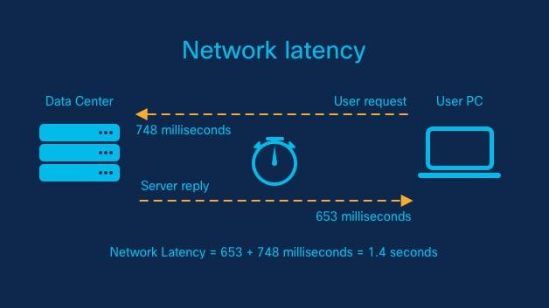
1.7 Cloud Network Logs and Metrics
A. Cloud Network Logs
Cloud network logs are records of events and activities that occur within cloud networking components such as virtual networks, servers, and load balancers.
Types of Cloud Network Logs
1. VPC Flow Logs
- Explanation: Capture information about IP traffic going to and from network interfaces within a Virtual Private Cloud (VPC).
- Contents: Source and destination IP addresses, ports and protocols, traffic status (accepted or rejected).
- Importance: Helps troubleshoot connectivity issues; detects unauthorized or suspicious traffic.
2. Load Balancer Logs
- Explanation: Record traffic handled by load balancers.
- Contents: Incoming requests, response status codes (e.g., 200, 404, 500), latency information.
- Importance: Identifies performance bottlenecks; monitors application availability.
3. Firewall and Security Logs
- Explanation: Generated by cloud firewalls and security groups.
- Contents: Allowed and denied traffic, intrusion attempts, policy enforcement actions.
- Importance: Enhances network security; supports threat detection and auditing.
4. DNS Logs
- Explanation: Track domain name resolution activities.
- Contents: DNS queries and responses, domain names accessed.
- Importance: Helps resolve domain-related issues; detects malicious domain access.
B. Cloud Network Metrics;
Metrics are numerical measurements that indicate the performance and health of cloud network systems.
Metric | Definition | Use
Latency | Time taken for data to travel across the network | Detects delays and slow response times
Throughput | Amount of data transferred over time | Measures network efficiency
Packet Loss | Percentage of packets that do not reach destination | Indicates congestion or network faults
Bandwidth Utilization | Amount of available bandwidth being used | Helps identify network overload

C. Cloud Monitoring Tools;
Cloud providers offer built-in tools for monitoring logs and metrics:
Cloud Provider | Monitoring Tool
Amazon Web Services (AWS) | CloudWatch, VPC Flow Logs
Microsoft Azure | Azure Monitor, Network Watcher
Google Cloud Platform (GCP) | Cloud Monitoring, Cloud Logging

Capabilities of these tools:
- Visualize metrics using dashboards
- Set alerts for unusual activity or thresholds
- Analyze logs in real time
- Create automated responses to incidents

D. Importance of Cloud Network Logs and Metrics
- Enable effective troubleshooting
- Provide real-time performance monitoring
- Improve security and compliance
- Assist in capacity planning and scaling
- Help detect and prevent network failures before they impact users
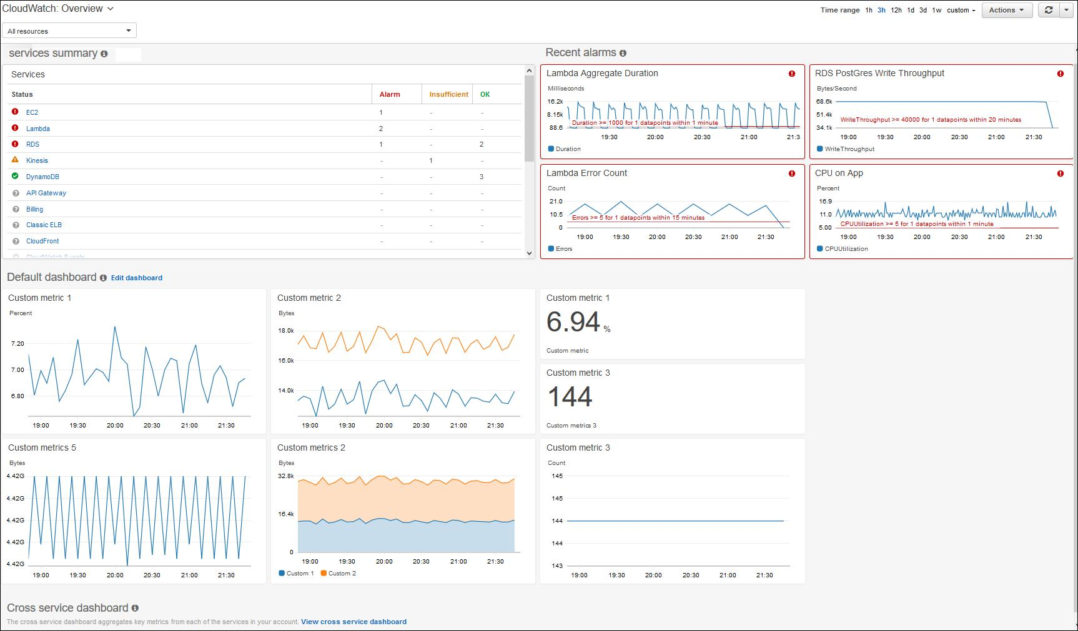

1.8 Issues Related to Cloud Network Configuration
A. Common Cloud Network Configuration Issues;
1. Misconfigured Security Groups and Firewalls
- Issue: Legitimate traffic is blocked or unauthorized access is allowed.
- Causes: Incorrect inbound and outbound rules; opening sensitive ports (e.g., SSH, RDP) to the public; overly permissive access (e.g., allowing `0.0.0.0/0` to all ports).
- Impact: Application inaccessibility; increased risk of cyberattacks.
2. Incorrect Routing Table Configuration
- Issue: Traffic does not reach its intended destination.
- Causes: Missing or incorrect routes; misconfigured default gateway; improper subnet routing.
- Impact: Network communication failure; isolated cloud resources.
3. Subnet Misconfiguration
- Issue: Poor network segmentation or resource isolation.
- Causes: Incorrect subnet allocation (too large or too small); mixing public and private resources improperly; overlapping subnet ranges.
- Impact: Security vulnerabilities; communication issues between services.
4. IP Addressing Issues
- Issue: Conflicts or invalid addressing disrupt communication.
- Causes: Duplicate IP addresses; incorrect CIDR block configuration; poor IP address planning (e.g., overlapping VPC CIDRs).
- Impact: Connectivity failures; service downtime.
5. DNS Configuration Errors
- Issue: Failure to resolve domain names.
- Causes: Incorrect DNS server settings; missing or wrong DNS records (A, CNAME, etc.); disabled DNS resolution in VPC settings.
- Impact: Inaccessible applications and services.
6. Load Balancer Misconfiguration
- Issue: Inefficient traffic distribution or service downtime.
- Causes: Incorrect backend server configuration (wrong IPs or instances); failed health checks; improper listener settings (wrong protocol or port).
- Impact: Uneven traffic load; poor application performance; service unavailability.
7. NAT and Internet Gateway Issues
- Issue: Resources cannot access the internet.
- Causes: Missing or unattached internet gateway; incorrect NAT gateway setup; routing misconfigurations (missing default route).
- Impact: Loss of external connectivity; failure to update or access external services.
B. Best Practices to Avoid Configuration Issues;
- Use proper network design and planning before deployment
- Apply the principle of least privilege for security rules
- Regularly review and audit configurations using Infrastructure as Code (IaC) tools
- Enable logging and monitoring tools from day one
- Use automation tools (e.g., Terraform, CloudFormation) to reduce human errors
- Test configurations in a staging environment before production
- Implement tagging and naming conventions for easier management
- Use configuration drift detection tools

Conclusion
Virtual and cloud network troubleshooting is essential for maintaining efficient, secure, and reliable IT systems. Understanding virtualization technologies, identifying common issues, analyzing logs and performance metrics, and properly configuring cloud networks are critical skills for network administrators and cloud engineers. By leveraging built-in monitoring tools, following best practices, and maintaining proactive troubleshooting strategies, organizations can ensure optimal performance, minimize downtime, and reduce security risks in both virtualized and cloud-based environments.

Referencess
- VMware, Inc. (2023). vSphere Networking Guide. VMware Documentation.
- Microsoft Corporation. (2023). Hyper-V Virtual Networking Overview. Microsoft Learn.
- Amazon Web Services. (2024). Amazon VPC User Guide. AWS Documentation.
- Google Cloud. (2024). VPC Networking Overview. Google Cloud Documentation.
- Morley, J. (2022). Mastering VMware vSphere 8. Wiley.
- Stallings, W. (2021). Computer Networking and Virtualization. Pearson.
- Wireshark Foundation. (2024). Wireshark User's Guide.
- Nagios Enterprises. (2023). Nagios Core Documentation.
- VMware, Inc. (n.d.). What is Network Virtualization? Retrieved from https://www.vmware.com/topics/network-virtualization

